MJ

Memo

|  |  |
| --- | --- |
| To: | Professor Londie Martin |
| From: | Makayla Johnson |
| Date: | June 25, 2023 |
| Re: | Project 4 |

**INTRODUCTION/PURPOSE**

This is our last project of this course. It is like the project we did last week but this one is more getting more into design and creating a book of our choose of topic. As always, my brain starts to think, and I thought of 2 ideas! One was a remake of the bob’s burger recipe but with my creativity and the other one was dealing with a NICU activity book. This last project was my favorite out of all because it gives off me becoming an author of my own and making my own book. The focus was based on typography, design and the importance of the audience. I wanted to do something I enjoy or relate too. I love anime and cartoons. I was a NICU baby, and my son was also.

**AUDIENCE DESCRIPTION**

My audience goes towards anyone that likes cooking and would like to try cooking recipes from the show bobs burger. The NICU activity book would correspond with people that work in that department in the hospital, parents who children are in the NICU. Children old enough to do activity book and all the doctors/nurses.

**CONTEXT/DESIGN CONSTRAINTS**

The design process was with ease! I looked over the original copy of the actual bobs burger cookbook and I just switched it around and did my own with my creativity. The NICU activity book was something I never seen or heard of before so it something I thought about out the box. The only problem was that I couldn’t think of enough related activity things to put that relates to NICU.

**DESIGN RATIONALE**

Bobs burgers cookery manual (title)

Picture of the family in the front

Author/introduction page

Table of contents (backwards numbers) 6 burgers and 1 dessert

Each burger recipe list of ingredients and the instructions with an image included.   
quote “signing off the burger way.” with the faces of the family.

Main color is yellow and red.

**EVOLUTION/REFLECTION**

My rough draft was good just had a few minor issues to fix as far as color and the readiness of the booklet itself. My classmates really enjoyed my rough drafts and the theme of the outcomes I came up with. Since I had more information on the bobs burger cookery manual then the NICU activity book so with the help of my professor I choose to stick with the Bobs Burger Cookery Manual.

**ROUGH DRAFT 1**

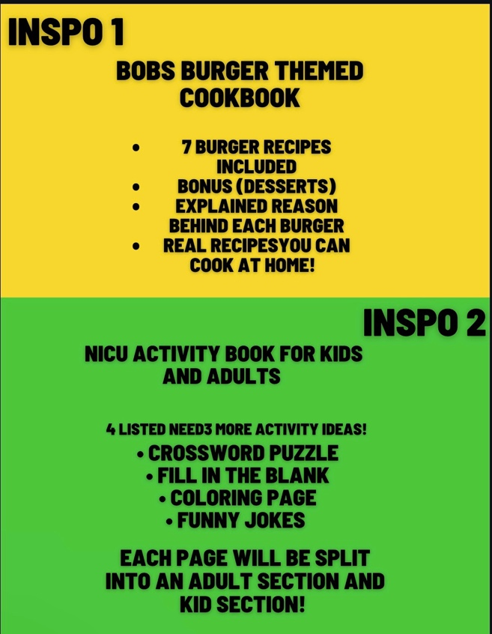

**ROUGH DRAFT 2**

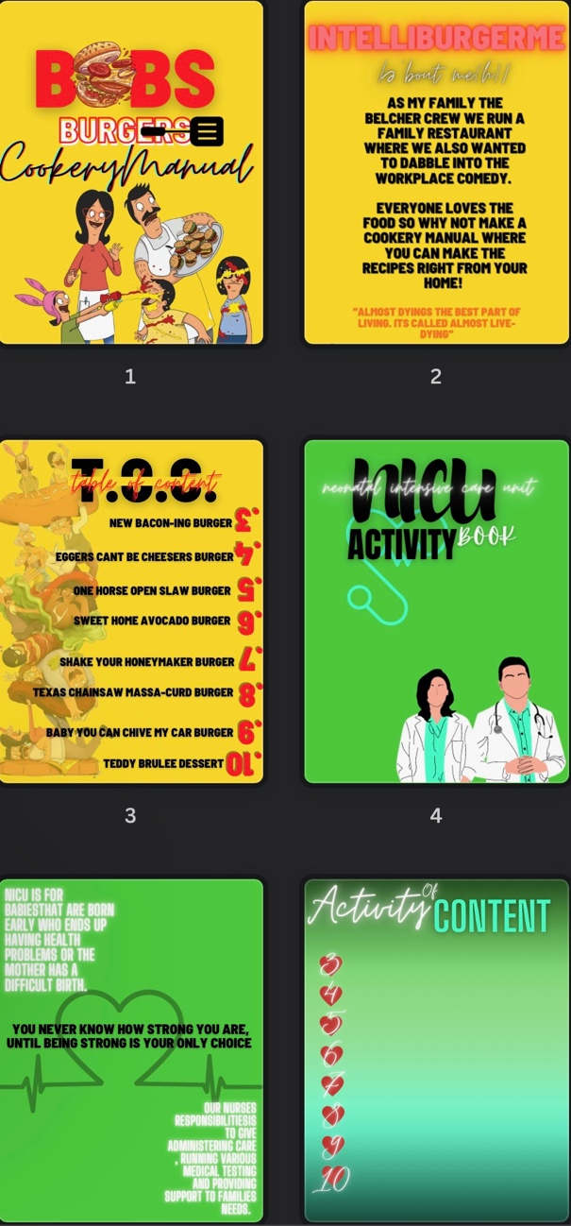

**FINAL LOGO**

